Project Design Phase
Solution Architecture

Date | 25/09/2026
Team ID | SWTID-2026-3184
Project Name | AI Study Buddy
Maximum Marks | 4 Marks

Solution Architecture:
The AI Study Buddy follows a web-based architecture in which students interact with the application through a user interface. The application processes user requests through the backend and provides AI-based study assistance. User information, study activities, quiz results, and progress data can be stored in a database.
Main Components
1.Student/User
- Provides questions and study-related inputs.
- Uses quizzes, study planning, and progress featurUser.
2.User Interface
- Provides the dashboard and study-related options.
- Allows students to interact with the system.
3.Backend/Application Server
- Processes user requests.
- Manages authentication and application logic.
- Connects the interface with the AI module and database.
4.AI Module
- Processes student queries.
- Provides study assistance.
- Supports personalized learning activities and quiz generation.
5.Database
- Stores user information.
- Stores study activities and quiz results.
- Maintains progress-related information.
6.Output
- AI responses
- Quiz questions and results
- Study activities
- Progress information

Example - Solution Architecture Diagram:
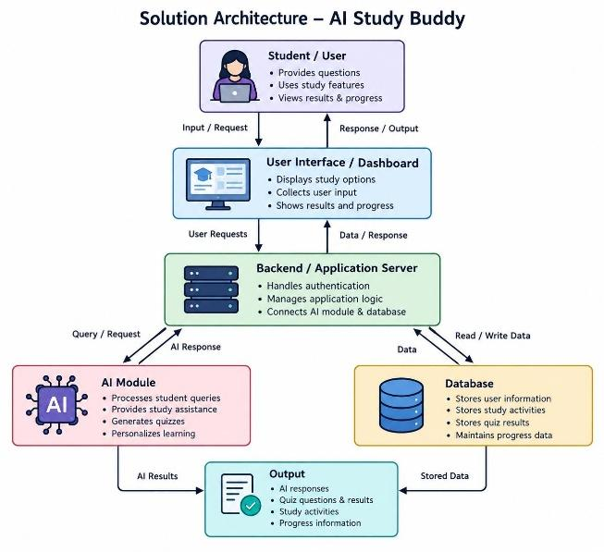

Reference: AI-Tutor System Architecture Diagrams, GitHub.

